**NNCI Monthly User Reporting Workflow**

***Author: William Veith | Last Edit: Apr 30, 2022***

**Table of Contents**

Workflow Overview

Initialize New Year

Generate MRC Event Docs

Generate MRC BillCodes Files

Generate MRC Stats XML Files

Generate TMI BillCodes Files from Raw TMI Data Files

Add TMI BillCodes Files to LabAccess Server

Generate TMI Stats XML Files

Generate “ALL_multi-stats-summary” Files

Generate Cumulative “ALL_multi-stats-summary” Files

Report NNCI User Statistics

# Workflow Overview

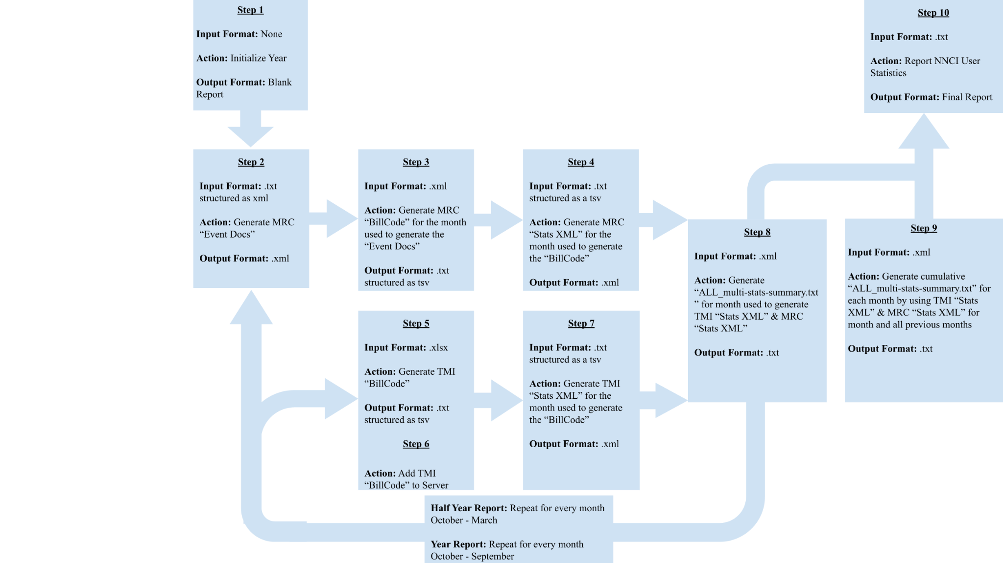

# Initialize New Year

* 1. Click: “Financial Report” Toolbar Menu in word document “Workflow”
  2. Click: “Create New Report”
  3. Input: The year the new report starts on
* *ex. 2022 for the 10/22 - 9/23 report*

# Generate MRC Event Docs

* 1. Open: “Reports” menu on the “Sedona LabSentry Server”
  2. Click: “select …” *“Select Event Files” window opens*
  3. Select: All event files for the desired month by holding down the shift key to select multiple files.
* *ex. For January select Sentry2022-01-01.txt through Sentry2022-01-31.txt (31 files in total)*
  1. Click: “OK” *“Select Event Files” window closes*

*“Creating Event Docs (misc days) for ut-labsentry(03)” will appear on screen while the the “Event Docs” are being generated*

# Generate MRC BillCodes Files

* 1. Open: “Reports” menu on the “Sedona LabSentry Server”
  2. Click: “Invoice” *“Invoice Controller” window opens*
  3. Click: “Create UserProfile Docs”
  4. Click: “Create TableCode Docs”
  5. Click: “Update System Config”
  6. Click: “Update User Config”
  7. Click: “Create Contacts Docs”
  8. Click: “Update Contacts Config”
  9. Click: “Save UserStats Docs”
  10. Click: “Export BillCode” *“Invoice Docs - Export.vi ToolboxXML Save Data.vi” window opens*
  11. Name File: File name must start with “MRC_”
  12. Click: “Save” *“Invoice Docs - Export.vi ToolboxXML Save Data.vi” window closes*
  13. Click: “OK” *“Invoice Controller” window closes*

# Generate MRC Stats XML Files

* 1. Open “Reports” menu on the “Sedona LabSentry Server”
  2. Click: “UserStats - MRC” *“BillCode Controller” window opens*
  3. Click: “Create UserProfile Docs”
  4. Click: “Select BillCode ..." *“Select Files” window opens*
  5. Select: BillCode for the desired month
  6. Click: “OK” *“Select Files” window closes*
  7. Click: “User Statistics” A popup window saying “No new users have been added.” may appear. Click “OK” if it appears
  8. Click: “Save UserStats Docs”
  9. Click: “Export Stats XML” *“Invoice Docs - Export.vi ToolboxXML Save Data.vi” window opens*
  10. Name File: File name must start with “MRC_”
  11. Click: “Save” *“Invoice Docs - Export.vi ToolboxXML Save Data.vi” window closes*
  12. Click: “OK” *“BillCode Controller” window closes*

# Generate TMI BillCodes Files from Raw TMI Data Files

* 1. Click: “Financial Report Data” Toolbar Menu in the google sheet containing the Newly Created Report
  2. Click: “Open”
  3. Click: “Open Raw Data Folder”
  4. Upload: TMI .xlsx files provided by the TMI admin
  5. Click: “Sanitize Raw Data”
  6. Click: “Digest Data”

*If an error popup window appears, fix all the data rows listed in the error report then click “Digest Data” again*

* 1. Click: “Download Digest”

# Add TMI BillCodes Files to LabAccess Server

* 1. Import: TMI BillCodes produced from raw TMI data use a flash-drive to transfer file
  2. Open Folder: “BillCodes” located in LabSentry(E:)
  3. Move: Imported TMI BillCode to “BillCodes” folder

# Generate TMI Stats XML Files

* 1. Open: “Reports” menu on the “Sedona LabSentry Server”
  2. Click: “UserStats - TMI” *“BillCode Controller” window opens*
  3. Click: “Create UserProfile Docs”
  4. Click: “Select BillCode ..." *“Select Files” window opens*
  5. Select: BillCode for the desired month
  6. Click: “OK” *“Select Files” window closes*
  7. Click: “User Statistics” A popup window saying “No new users have been added.” may appear. Click “OK” if it appears
  8. Click: “Save UserStats Docs”
  9. Click: “Export Stats XML” *“Invoice Docs - Export.vi ToolboxXML Save Data.vi” window opens*
  10. Name File: File name must start with “TMI_”
  11. Click: “Save” *“Invoice Docs - Export.vi ToolboxXML Save Data.vi” window closes*
  12. Click: “OK” *“BillCode Controller” window closes*

# Generate “ALL_multi-stats-summary” Files

* 1. Open “Reports” menu on the “Sedona LabSentry Server”
  2. Click: “MultiStats - All” *“MultiStats Controller” window opens*
  3. Click: “Select Stats XML …” *“Select Files” window opens*
  4. Select: TMI user stats xml file & MRC user stats xml file for the desired month hold down on shift key to select multiple files
  5. Click: “OK” *“Select Files” window closes*
  6. Click: “Save UserStats Docs”
  7. Click: “Export Stats Results”
  8. Click: “Stats Results Folder” *“StatsResults folder window will open”*
  9. Rename File: “ALL_multi-stats-summary.txt” to year-month-stats-summary.txt
* *ex. 2022-10-stats-summary.txt*

# Generate Cumulative “ALL_multi-stats-summary” Files

* 1. Open “Reports” menu on the “Sedona LabSentry Server”
  2. Click: “MultiStats - All” *“MultiStats Controller” window opens*
  3. Click: “Select Stats XML …” *“Select Files” window opens*
  4. Select: All TMI & MRC user stats xml files from October to the desired month; hold down shift key to select multiple files
* *ex. For January select October MRC, October TMI, November MRC, November TMI, December MRC, December TMI, January MRC, and January TMI user stats xml files*
  1. Click: “OK” “Select Files” window closes
  2. Click: “Save UserStats Docs”
  3. Click: “Export Stats Results”
  4. Click: “Stats Results Folder” “StatsResults” folder window will open
  5. Rename File: “ALL_multi-stats-summary.txt” to year-month_previous year-10_cumulative-stats-summary.txt
* *ex. For January 2022-01_2021-10_cumulative-stats-summary.txt*

# Report NNCI User Statistics

* 1. Click Tab: “Financial Report Data” in the google sheet containing the Newly Created Report
  2. Click: “Open”
  3. Click: “Open Stats Summary Folder”
  4. Upload the generated Cumulative and Monthly Stats Summaries to the monthly and cumulative folders
  5. Click “Insert User Stat Summary Data